|  |  |  |
| --- | --- | --- |
| **Name** | **ID** | **STUDENT SIGN** |
| FARJANA YESMIN OPI | 22-47018-1 |  |

**Instructions:**

* **Make sure to write your Name, ID and Signature on this document.**
* **First write your signature on a paper then take photo of that signature and use it for signing this document.**
* **After completing the requirements of the midterm assignment by editing this document, upload this document in the link provided in your VUES Student Account.**

**Midterm Assignment**

1. **Below a scenario has been given draw the ER Diagram.**

***Draw with proper annotations (use DIA, VISIO, MS WORD etc.).*** ***For reference see ERDiagramTutorial.***

In a doctor appointment management system, a patient takes appointment from a doctor and a doctor attend appointment of many patients. A doctor is identified by doctor id, name, address, room no, qualification, specialty, visit, and contact no. There may be multiple contact no of a doctor. A Patient is identified by their unique ID and the system stores their name, mobile number, age and address. A patient address is composed of city name, street number, and house number. One doctor can be associated with many chambers, but one chamber is associated with only one doctor and the system stores the id and address of each chamber, including the city name, street number, and house number. Additionally, one doctor has many compounders, but a compounder is associated with only one doctor and a compounder is identified by their ID, name, and contact numbers. A chamber is maintained by only one compounder and a compounder maintain only one chamber. While taking appointment, the date and time of appointment for each patient is also stored. Furthermore, one doctor can have many schedules, but each schedule is associated with only one doctor and the system stores the id, time and date for each schedule and a compounder can manage many schedules for doctor, but a schedule is managed by one compounder.

Answer 1:

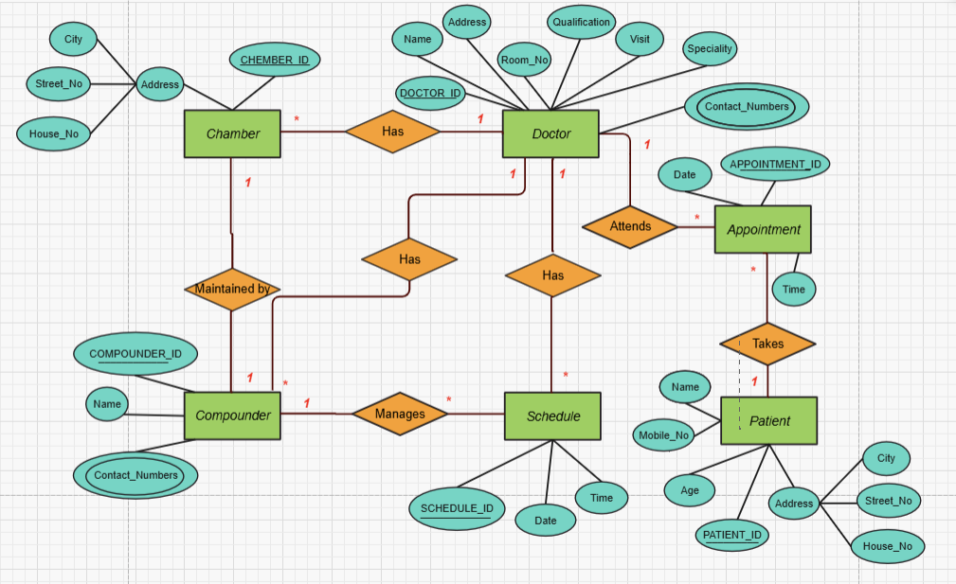

1. **Below an ER Diagram has been given write the scenario.**

***For reference see ERDiagramTutorial.***

1. **Below an ER Diagram has been given write the scenario.**

***For reference see ERDiagramTutorial.***

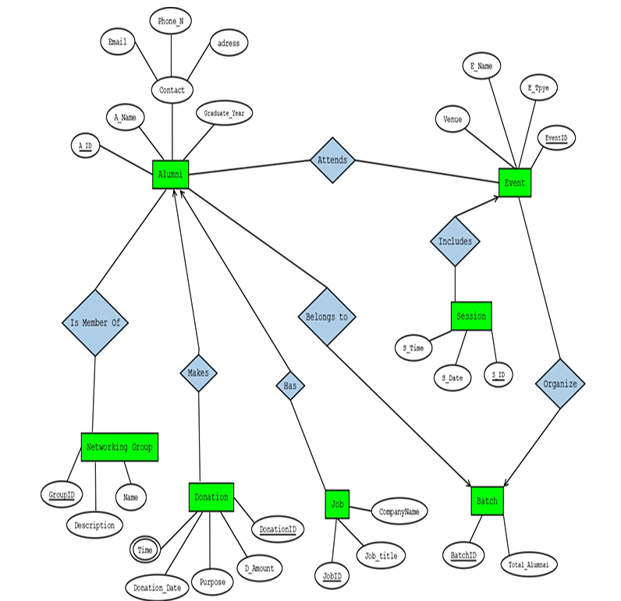

Answer 2:

An Alumni Management System is designed to manage alumni details, their participation in events, donations, networking groups, jobs, and batch records. An alumni member is identified by an alumni ID. The system also stores alumni name, graduation year, contact details, which include email, phone number, and address. An alumni member belongs to exactly one batch, and a batch consists of many alumni members. A batch is identified by a batch ID, and the system also stores the total number of alumni in the batch. A batch organizes multiple events, and an event is associated with multiple batches. Alumni attends events. An event is identified by an event ID. The system also stores the event name, event type, and venue. An alumni member may attend many events, and an event may be attended by many alumni members. An event includes one or more sessions, and each session has a session ID, session date, and session time. Session is identified by a session ID. A session belongs to exactly one event. An alumni member may make multiple donations, and a donation is uniquely identified by a donation ID. The system also stores the donation amount, donation date, time and purpose. An alumni member is member of multiple networking groups, and a networking group consists of multiple alumni members. A networking group is identified by a group ID, and the system stores the group name and description. An alumni member has jobs, and a job is uniquely identified by a job ID. The system stores the job title and company name. An alumni member may have multiple jobs.

1. **Normalize the ER Diagram given below up to 3rd Normal Form and finalize the tables that needs to be created. Then (in Oracle using SQL) write down the queries that are required to create all the tables with necessary constraints. Also insert at least 3 rows of data in each created table.**

***For reference see NormalizationTutorial and BasicSQLTutorial.***

Answer Box (Normalization steps in detail as shown in Normalization Tutorial Slide + all the queries required to create the tables and insert data after Normalization):

**Answer:**

Operate by

**UNF:**

Operate by(Driver_Id, First_Name, Last_Name, License_Number, Experience_Year, Bus_Number, Type, Model, Capacity)

**1NF:**

There is no multivalued attribute. Relation is already in 1NF.

1. Driver_Id, First_Name, Last_Name, License_Number, Experience_Year,

Bus_Number, Type, Model, Capacity

**2NF:**

1. Driver_Id, First_Name, Last_Name, License_Number, Experience_Year
2. Bus_Number, Type, Model, Capacity

**3NF:**

Name is transitive attribute.

1. Driver_Id, License_Number, Experience_Year
2. First_Name, Last_Name
3. Bus_Number, Type, Model, Capacity

**Table Creation:**

1. Driver_Id, License_Number, Experience_Year, Bus_Number, N_Id
2. N_Id, First_Name, Last_Name
3. Bus_Number, Type, Model, Capacity

Follows:

**UNF:**

Follows( Bus_Number, Type, Model, Capacity, Route_Id , Start_Location, End_Location, Distance, Departure_Time)

**1NF:**

There is no multivalued attribute. Relation is already in 1NF.

1. Bus_Number, Type, Model, Capacity, Route_Id , Start_Location, End_Location, Distance, Departure_Time

**2NF:**

1. Bus_Number, Type, Model, Capacity
2. Route_Id , Start_Location, End_Location, Distance, Departure_Time

**3NF:**

Destination is transitive attribute.

1. Bus_Number, Type, Model, Capacity
2. Route_Id , Distance, Departure_Time
3. Start_Location, End_Location

**Table Creation:**

1. Bus_Number, Type, Model, Capacity,
2. Route_Id , Distance, Departure_Time, Bus_Number, L_Id
3. L_Id, Start_Location, End_Location

Conducts

**UNF:**

Conducts( Bus_Number, Type, Model, Capacity, Supervisor_Id, First_Name, Last_Name, Experience_Year)

**1NF:**

There is no multivalued attribute. Relation is already in 1NF.

1. Bus_Number, Type, Model, Capacity, Supervisor_Id, First_Name, Last_Name, Experience_Year

**2NF:**

1. Bus_Number, Type, Model, Capacity
2. Supervisor_Id, First_Name, Last_Name, Experience_Year

**3NF:**

Name is Transitive attribute.

1. Bus_Number, Type, Model, Capacity
2. Supervisor_Id, Experience_Year
3. First_Name, Last_Name

**Table Creation:**

1. Bus_Number, Type, Model, Capacity
2. Supervisor_Id, Experience_Year, Bus_Number, N_Id
3. N_Id, First_Name, Last_Name.

Assign

**UNF:**

Assign (Bus_Number, Type, Model, Capacity, Ticket_Number, Ticket_Status, Ticket_Price, Seat_Number)

**1NF:**

There is no multivalued attribute. Relation is already in 1NF.

1. Bus_Number, Type, Model, Capacity, Ticket_Number, Ticket_Status, Ticket_Price, Seat_Number

**2NF:**

1. Bus_Number, Type, Model, Capacity
2. Ticket_Number, Ticket_Status, Ticket_Price, Seat_Number

**3NF:**

There is no transitive attribute. Relation is already in 3NF.

1. Bus_Number, Type, Model, Capacity
2. Ticket_Number, Ticket_Status, Ticket_Price, Seat_Number

**Table Creation:**

1. Bus_Number, Type, Model, Capacity
2. Ticket_Number, Ticket_Status, Ticket_Price, Seat_Number, Bus_Number

Buy

**UNF:**

Buy(Ticket_Number, Ticket_Status, Ticket_Price, Seat_Number, National_Id, First_Name, Last_Name, Gender, Phone_Number)

**1NF:**

Phone_Number is multivalued attribute.

1. Ticket_Number, Ticket_Status, Ticket_Price, Seat_Number, National_Id, First_Name, Last_Name, Gender, Phone_Number

**2NF:**

1. Ticket_Number, Ticket_Status, Ticket_Price, Seat_Number
2. National_Id, First_Name, Last_Name, Gender, Phone_Number

**3NF:**

Name is transitive attribute.

1. Ticket_Number, Ticket_Status, Ticket_Price, Seat_Number
2. National_Id, Gender, Phone_Number
3. First_Name, Last_Name

**Table Creation:**

1. Ticket_Number, Ticket_Status, Ticket_Price, Seat_Number, National_Id, N_Id
2. National_Id, Gender, Phone_Number
3. N_Id, First_Name, Last_Name

Makes

**UNF:**

Makes(National_Id, First_Name, Last_Name, Gender, Phone_Number, Transaction_Id, Date, Total_Amount)

**1NF:**

Phone_Number is multivalued attribute.

1. National_Id, First_Name, Last_Name, Gender, Phone_Number, Transaction_Id, Date, Total_Amount

**2NF:**

1. National_Id, First_Name, Last_Name, Gender, Phone_Number
2. Transaction_Id, Date, Total_Amount

**3NF:**

Name is transitive attribute.

1. National_Id, Gender, Phone_Number
2. First_Name, Last_Name,
3. Transaction_Id, Date, Total_Amount

**Table Creation:**

1. National_Id, Gender, Phone_Number
2. N_Id, First_Name, Last_Name
3. Transaction_Id, Date, Total_Amount, National_Id, N_Id

Contains

**UNF:**

Contains( Ticket_Number, Ticket_Status, Ticket_Price, Seat_Number, Transaction_Id, Date, Total_Amount.)

**1NF:**

There is no multivalued attribute. Relation is already in 1NF.

1. Ticket_Number, Ticket_Status, Ticket_Price, Seat_Number, Transaction_Id, Date, Total_Amount

**2NF:**

1. Ticket_Number, Ticket_Status, Ticket_Price, Seat_Number
2. Transaction_Id, Date, Total_Amount

**3NF:**

There is no transitive attribute.

1. Ticket_Number, Ticket_Status, Ticket_Price, Seat_Number
2. Transaction_Id, Date, Total_Amount

**Table Creation:**

1. Ticket_Number, Ticket_Status, Ticket_Price, Seat_Number, Transaction_Id
2. Transaction_Id, Date, Total_Amount

Uses

**UNF:**

Uses(Transaction_Id, Date, Total_Amount, Payment_Code, Payment_Method, Payment_Type)

**1NF:**

There is no multivalued attribute. Relation is already in 1NF.

1. Transaction_Id, Date, Total_Amount, Payment_Code, Payment_Method, Payment_Type

**2NF:**

1. Transaction_Id, Date, Total_Amount
2. Payment_Code, Payment_Method, Payment_Type

**3NF:**

There is no transitive attribute. Relation is already in 3NF.

1. Transaction_Id, Date, Total_Amount
2. Payment_Code, Payment_Method, Payment_Type

**Table Creation:**

1. Transaction_Id, Date, Total_Amount
2. Payment_Code, Payment_Method, Payment_Type, Transaction_Id

Issues

**UNF:**

Issues(Supervisor_Id, First_Name, Last_Name, Experience_Year, Ticket_Number, Ticket_Status, Ticket_Price, Seat_Number)

**1NF:**

There is no multivalued attribute. Relation is already in 1NF.

1. Supervisor_Id, First_Name, Last_Name, Experience_Year, Ticket_Number, Ticket_Status, Ticket_Price, Seat_Number.

**2NF:**

1. Supervisor_Id, First_Name, Last_Name, Experience_Year
2. Ticket_Number, Ticket_Status, Ticket_Price, Seat_Number

**3NF:**

Name is transitive attribute.

1. Supervisor_Id, Experience_Year
2. First_Name, Last_Name
3. Ticket_Number, Ticket_Status, Ticket_Price, Seat_Number

**Table Creation:**

1. Supervisor_Id, Experience_Year.
2. N_Id, First_Name, Last_Name.
3. Ticket_Number, Ticket_Status, Ticket_Price, Seat_Number, Supervisor_Id, N_Id

**Temporary Tables:**

1. Driver_Id, License_Number, Experience_Year, Bus_Number, N_Id
2. N_Id, First_Name, Last_Name
3. Bus_Number, Type, Model, Capacity
4. ~~Bus_Number, Type, Model, Capacity~~
5. Route_Id , Distance, Departure_Time, Bus_Number, L_Id
6. L_Id, Start_Location, End_Location
7. ~~Bus_Number, Type, Model, Capacity~~
8. Supervisor_Id, Experience_Year, Bus_Number, N_Id
9. ~~N_Id, First_Name, Last_Name.~~
10. ~~Bus_Number, Type, Model, Capacity~~
11. Ticket_Number, Ticket_Status, Ticket_Price, Seat_Number, Bus_Number
12. Ticket_Number, Ticket_Status, Ticket_Price, Seat_Number, National_Id, N_Id
13. National_Id, Gender, Phone_Number
14. ~~National_Id, Gender, Phone_Number~~
15. ~~N_Id, First_Name, Last_Name~~
16. Transaction_Id, Date, Total_Amount, National_Id, N_Id
17. Ticket_Number, Ticket_Status, Ticket_Price, Seat_Number, Transaction_Id
18. Transaction_Id, Date, Total_Amount
19. ~~Transaction_Id, Date, Total_Amount~~
20. Payment_Code, Payment_Method, Payment_Type, Transaction_Id
21. Supervisor_Id, Experience_Year
22. ~~N_Id, First_Name, Last_Name~~
23. Ticket_Number, Ticket_Status, Ticket_Price, Seat_Number, Supervisor_Id, N_Id

**Final Tables:**

1. Driver_Id, License_Number, Experience_Year, Bus_Number, N_Id
2. N_Id, First_Name, Last_Name
3. Bus_Number, Type, Model, Capacity
4. Route_Id , Distance, Departure_Time, Bus_Number, L_Id
5. L_Id, Start_Location, End_Location
6. Supervisor_Id, Experience_Year, Bus_Number, N_Id
7. Ticket_Number, Ticket_Status, Ticket_Price, Seat_Number, Bus_Number
8. Ticket_Number, Ticket_Status, Ticket_Price, Seat_Number, National_Id, N_Id
9. National_Id, Gender, Phone_Number
10. Transaction_Id, Date, Total_Amount, National_Id, N_Id
11. Ticket_Number, Ticket_Status, Ticket_Price, Seat_Number, Transaction_Id
12. Transaction_Id, Date, Total_Amount
13. Payment_Code, Payment_Method, Payment_Type, Transaction_Id
14. Supervisor_Id, Experience_Year
15. Ticket_Number, Ticket_Status, Ticket_Price, Seat_Number, Supervisor_Id, N_Id

**Table Creation:**

**1. Driver Table:**

CREATE TABLE Driver (

Driver_Id INT PRIMARY KEY,

License_Number VARCHAR(50),

Experience_Year INT,

Bus_Number VARCHAR(20),

N_Id VARCHAR(20)

);

**2. Person Table**

CREATE TABLE Person (

N_Id VARCHAR(20) PRIMARY KEY,

First_Name VARCHAR(50),

Last_Name VARCHAR(50)

);

**3. Bus Table**

CREATE TABLE Bus (

Bus_Number VARCHAR(20) PRIMARY KEY,

Type VARCHAR(30),

Model VARCHAR(50),

Capacity INT

);

**4. Route Table**

CREATE TABLE Route (

Route_Id NUMBER PRIMARY KEY,

Distance NUMBER,

Departure_Time DATE,

Bus_Number VARCHAR2(20),

L_Id NUMBER,

FOREIGN KEY (L_Id) REFERENCES Location(L_Id)

);

**5.Location Table**

CREATE TABLE Location (

L_Id INT PRIMARY KEY,

Start_Location VARCHAR(100),

End_Location VARCHAR(100)

);

**6. Supervisor Table**

CREATE TABLE Supervisor (

Supervisor_Id NUMBER PRIMARY KEY,

Experience_Year NUMBER,

Bus_Number VARCHAR2(20),

N_Id VARCHAR2(20),

FOREIGN KEY (N_Id) REFERENCES Person(N_Id)

);

**7. Ticket Table**

CREATE TABLE Ticket (

Ticket_Number INT PRIMARY KEY,

Ticket_Status VARCHAR(20),

Ticket_Price DECIMAL(10, 2),

Seat_Number INT,

Bus_Number VARCHAR(20)

);

**8. Ticket_Person Table**

CREATE TABLE Ticket_Person (

Ticket_Number NUMBER,

Ticket_Status VARCHAR2(20),

Ticket_Price NUMBER(10, 2),

Seat_Number NUMBER,

National_Id VARCHAR2(20),

N_Id VARCHAR2(20),

FOREIGN KEY (N_Id) REFERENCES Person(N_Id),

FOREIGN KEY (National_Id) REFERENCES Nationality(National_Id)

);

**9. Nationality Table**

CREATE TABLE National (

National_Id VARCHAR(20) PRIMARY KEY,

Gender VARCHAR(10),

Phone_Number VARCHAR(15)

);

**10. Transaction_Record Table**

CREATE TABLE Transaction_Record (

Transaction_Id NUMBER PRIMARY KEY,

Transaction_Date DATE,

Total_Amount NUMBER(10, 2),

National_Id VARCHAR2(20),

N_Id VARCHAR2(20),

FOREIGN KEY (N_Id) REFERENCES Person(N_Id),

FOREIGN KEY (National_Id) REFERENCES Nationality(National_Id)

);

**11. Ticket_Transaction Table**

CREATE TABLE Ticket_Transaction (

Ticket_Number NUMBER,

Ticket_Status VARCHAR2(20),

Ticket_Price NUMBER(10, 2),

Seat_Number NUMBER,

Transaction_Id NUMBER,

FOREIGN KEY (Transaction_Id) REFERENCES Transaction_Record(Transaction_Id)

);

**12. Transaction_Info Table**

CREATE TABLE Transaction_Info (

Transaction_Id NUMBER PRIMARY KEY,

Transaction_Date DATE,

Total_Amount NUMBER(10, 2)

);

**13. Payment Table**

CREATE TABLE Payment (

Payment_Code NUMBER PRIMARY KEY,

Payment_Method VARCHAR2(50),

Payment_Type VARCHAR2(50),

Transaction_Id NUMBER,

FOREIGN KEY (Transaction_Id) REFERENCES Transaction_Record(Transaction_Id)

);

**14. Supervisor_Info Table**

CREATE TABLE Supervisor_Info (

Supervisor_Id INT PRIMARY KEY,

Experience_Year INT

);

**15. Ticket_Supervisor Table**

CREATE TABLE Ticket_Supervisor (

Ticket_Number NUMBER,

Ticket_Status VARCHAR2(20),

Ticket_Price NUMBER(10, 2),

Seat_Number NUMBER,

Supervisor_Id NUMBER,

N_Id VARCHAR2(20),

FOREIGN KEY (N_Id) REFERENCES Person(N_Id),

FOREIGN KEY (Supervisor_Id) REFERENCES Supervisor_Info(Supervisor_Id)

);

**Value Insert:**

**1. Driver Table**

INSERT INTO Driver (Driver_Id, License_Number, Experience_Year, Bus_Number, N_Id)

VALUES (1, 'LIC1001', 5, 'BUS101', 'P001');

INSERT INTO Driver (Driver_Id, License_Number, Experience_Year, Bus_Number, N_Id)

VALUES (2, 'LIC1002', 7, 'BUS102', 'P002');

INSERT INTO Driver (Driver_Id, License_Number, Experience_Year, Bus_Number, N_Id)

VALUES (3, 'LIC1003', 4, 'BUS103', 'P003');

**2. Person Table**

INSERT INTO Person (N_Id, First_Name, Last_Name) VALUES ('P001', 'Ali', 'Hassan');

INSERT INTO Person (N_Id, First_Name, Last_Name) VALUES ('P002', 'Sara', 'Rahman');

INSERT INTO Person (N_Id, First_Name, Last_Name) VALUES ('P003', 'Kamal', 'Uddin');

**3. Bus Table**

INSERT INTO Bus (Bus_Number, Type, Model, Capacity) VALUES ('BUS101', 'AC', 'Volvo', 40);

INSERT INTO Bus (Bus_Number, Type, Model, Capacity) VALUES ('BUS102', 'Non-AC', 'Isuzu', 35);

INSERT INTO Bus (Bus_Number, Type, Model, Capacity) VALUES ('BUS103', 'AC', 'Hyundai', 45);

**4. Route Table**

INSERT INTO Route (Route_Id, Distance, Departure_Time, Bus_Number, L_Id)

VALUES (101, 250, TO_DATE('2025-04-10 08:00:00', 'YYYY-MM-DD HH24:MI:SS'), 'BUS101', 1);

INSERT INTO Route (Route_Id, Distance, Departure_Time, Bus_Number, L_Id)

VALUES (102, 300, TO_DATE('2025-04-11 07:30:00', 'YYYY-MM-DD HH24:MI:SS'), 'BUS102', 2);

INSERT INTO Route (Route_Id, Distance, Departure_Time, Bus_Number, L_Id)

VALUES (103, 180, TO_DATE('2025-04-12 09:00:00', 'YYYY-MM-DD HH24:MI:SS'), 'BUS103', 3);

**5.Location Table**

INSERT INTO Location (L_Id, Start_Location, End_Location) VALUES (1, 'Dhaka', 'Chittagong');

INSERT INTO Location (L_Id, Start_Location, End_Location) VALUES (2, 'Sylhet', 'Rajshahi');

INSERT INTO Location (L_Id, Start_Location, End_Location) VALUES (3, 'Khulna', 'Barisal');

**6. Supervisor Table**

INSERT INTO Supervisor (Supervisor_Id, Experience_Year, Bus_Number, N_Id)

VALUES (201, 8, 'BUS101', 'P001');

INSERT INTO Supervisor (Supervisor_Id, Experience_Year, Bus_Number, N_Id)

VALUES (202, 5, 'BUS102', 'P002');

INSERT INTO Supervisor (Supervisor_Id, Experience_Year, Bus_Number, N_Id)

VALUES (203, 10, 'BUS103', 'P003');

**7. Ticket Table**

INSERT INTO Ticket (Ticket_Number, Ticket_Status, Ticket_Price, Seat_Number, Bus_Number)

VALUES (1001, 'Confirmed', 500.00, 1, 'BUS101');

INSERT INTO Ticket (Ticket_Number, Ticket_Status, Ticket_Price, Seat_Number, Bus_Number)

VALUES (1002, 'Pending', 450.00, 2, 'BUS102');

INSERT INTO Ticket (Ticket_Number, Ticket_Status, Ticket_Price, Seat_Number, Bus_Number)

VALUES (1003, 'Cancelled', 600.00, 3, 'BUS103');

**8. Ticket_Person Table**

INSERT INTO Ticket_Person (Ticket_Number, Ticket_Status, Ticket_Price, Seat_Number, National_Id, N_Id)

VALUES (1001, 'Confirmed', 500.00, 1, 'NAT001', 'P001');

INSERT INTO Ticket_Person (Ticket_Number, Ticket_Status, Ticket_Price, Seat_Number, National_Id, N_Id)

VALUES (1002, 'Pending', 450.00, 2, 'NAT002', 'P002');

INSERT INTO Ticket_Person (Ticket_Number, Ticket_Status, Ticket_Price, Seat_Number, National_Id, N_Id)

VALUES (1003, 'Cancelled', 600.00, 3, 'NAT003', 'P003');

**9. Nationality Table**

INSERT INTO Nationality (National_Id, Gender, Phone_Number) VALUES ('NAT001', 'Male', '0123456789');

INSERT INTO Nationality (National_Id, Gender, Phone_Number) VALUES ('NAT002', 'Female', '0987654321');

INSERT INTO Nationality (National_Id, Gender, Phone_Number) VALUES ('NAT003', 'Male', '0112233445');

**10. Transaction_Record Table**

INSERT INTO Transaction_Record (Transaction_Id, Transaction_Date, Total_Amount, National_Id, N_Id)

VALUES (301, TO_DATE('2025-04-10', 'YYYY-MM-DD'), 500.00, 'NAT001', 'P001');

INSERT INTO Transaction_Record (Transaction_Id, Transaction_Date, Total_Amount, National_Id, N_Id)

VALUES (302, TO_DATE('2025-04-11', 'YYYY-MM-DD'), 450.00, 'NAT002', 'P002');

INSERT INTO Transaction_Record (Transaction_Id, Transaction_Date, Total_Amount, National_Id, N_Id)

VALUES (303, TO_DATE('2025-04-12', 'YYYY-MM-DD'), 600.00, 'NAT003', 'P003');

**11. Ticket_Transaction Table**

INSERT INTO Ticket_Transaction (Ticket_Number, Ticket_Status, Ticket_Price, Seat_Number, Transaction_Id)

VALUES (1001, 'Confirmed', 500.00, 1, 301);

INSERT INTO Ticket_Transaction (Ticket_Number, Ticket_Status, Ticket_Price, Seat_Number, Transaction_Id)

VALUES (1002, 'Pending', 450.00, 2, 302);

INSERT INTO Ticket_Transaction (Ticket_Number, Ticket_Status, Ticket_Price, Seat_Number, Transaction_Id)

VALUES (1003, 'Cancelled', 600.00, 3, 303);

**12. Transaction_Info Table**

INSERT INTO Transaction_Info (Transaction_Id, Transaction_Date, Total_Amount)

VALUES (301, TO_DATE('2025-04-10', 'YYYY-MM-DD'), 500.00);

INSERT INTO Transaction_Info (Transaction_Id, Transaction_Date, Total_Amount)

VALUES (302, TO_DATE('2025-04-11', 'YYYY-MM-DD'), 450.00);

INSERT INTO Transaction_Info (Transaction_Id, Transaction_Date, Total_Amount)

VALUES (303, TO_DATE('2025-04-12', 'YYYY-MM-DD'), 600.00);

**13. Payment Table**

INSERT INTO Payment (Payment_Code, Payment_Method, Payment_Type, Transaction_Id)

VALUES (401, 'Bkash', 'Mobile', 301);

INSERT INTO Payment (Payment_Code, Payment_Method, Payment_Type, Transaction_Id)

VALUES (402, 'Card', 'Credit', 302);

INSERT INTO Payment (Payment_Code, Payment_Method, Payment_Type, Transaction_Id)

VALUES (403, 'Cash', 'Manual', 303);

**14. Supervisor_Info Table**

INSERT INTO Supervisor_Info (Supervisor_Id, Experience_Year)

VALUES (201, 8);

INSERT INTO Supervisor_Info (Supervisor_Id, Experience_Year)

VALUES (202, 5);

INSERT INTO Supervisor_Info (Supervisor_Id, Experience_Year)

VALUES (203, 10);

**15. Ticket_Supervisor Table**

INSERT INTO Ticket_Supervisor (Ticket_Number, Ticket_Status, Ticket_Price, Seat_Number, Supervisor_Id, N_Id)

VALUES (1001, 'Confirmed', 500.00, 1, 201, 'P001');

INSERT INTO Ticket_Supervisor (Ticket_Number, Ticket_Status, Ticket_Price, Seat_Number, Supervisor_Id, N_Id)

VALUES (1002, 'Pending', 450.00, 2, 202, 'P002');

INSERT INTO Ticket_Supervisor (Ticket_Number, Ticket_Status, Ticket_Price, Seat_Number, Supervisor_Id, N_Id)

VALUES (1003, 'Cancelled', 600.00, 3, 203, 'P003');

1. **Query Writing (Write down the question and the answer. Give full screenshot of the Oracle 10g Homepage that contains the answer and result)**

**-All screenshots MUST include the DATE and TIME feature from the screen of the machine (PC, Laptop etc.) used**

**SQL**

**-2 single-row function**

**-2 group function**

**-2 subquery**

**-2 joining**

***For reference see BasicSQLTutorial and AdvanceSQLTutorial.***

Answer 4:

**-2 single-row function**

**Question:** Display the first name of all persons in uppercase.

1. SELECT UPPER(First_Name) AS Uppercase_Name FROM Person;

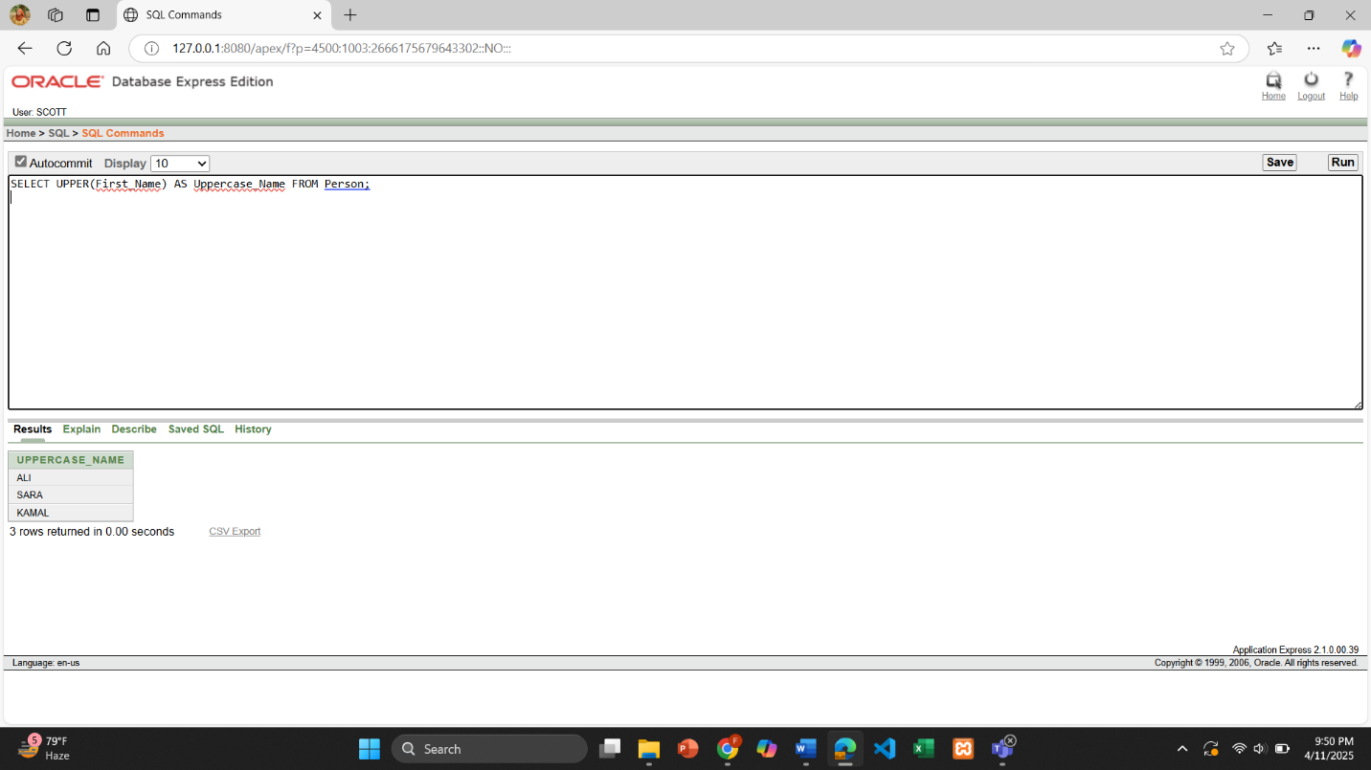

**Question:** Show the length of each driver’s license number.

2. SELECT License_Number, LENGTH(License_Number) AS License_Length FROM Driver;

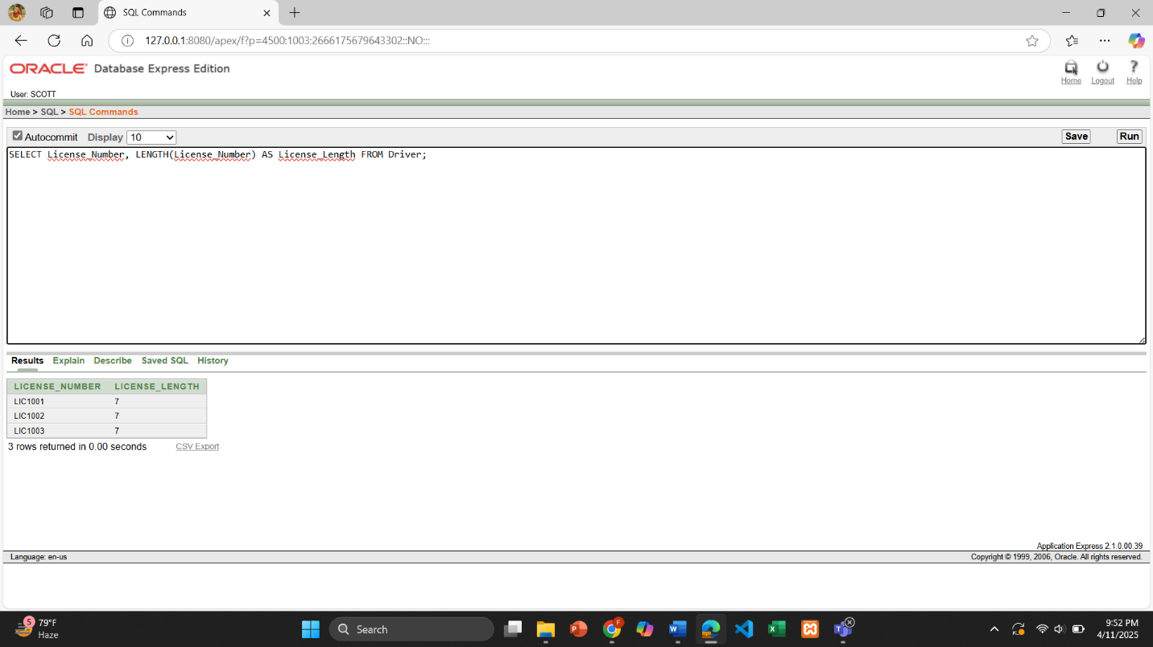

**2 group function**

**Question:** Find the average capacity of all buses.

1. SELECT AVG(Capacity) AS Average_Capacity FROM Bus;

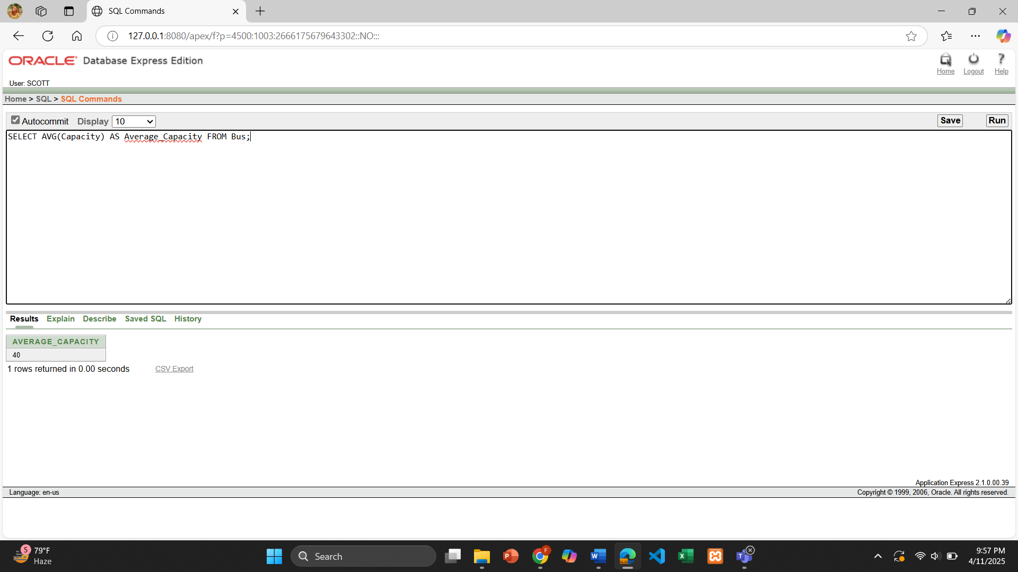

**Question:** Count the total number of tickets issued.

2. SELECT COUNT(Ticket_Number) AS Total_Tickets FROM Ticket;

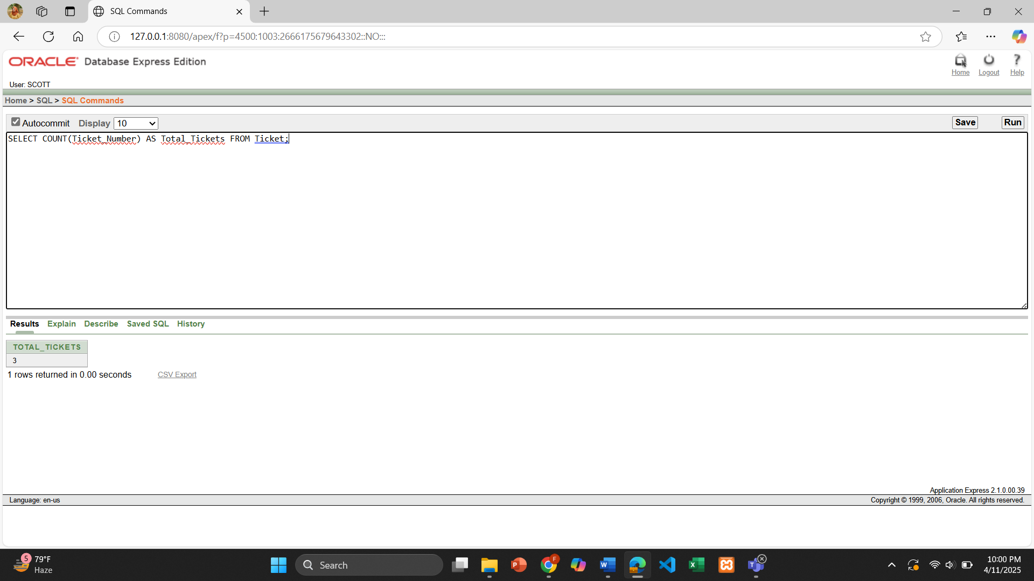

**2 subquery**

**Question :** Find the name of the person who paid the highest amount in a transaction.

1. SELECT First_Name, Last_Name

FROM Person

WHERE N_Id = (

SELECT N_Id

FROM Transaction_Record

WHERE Total_Amount = (

SELECT MAX(Total_Amount) FROM Transaction_Record

)

);

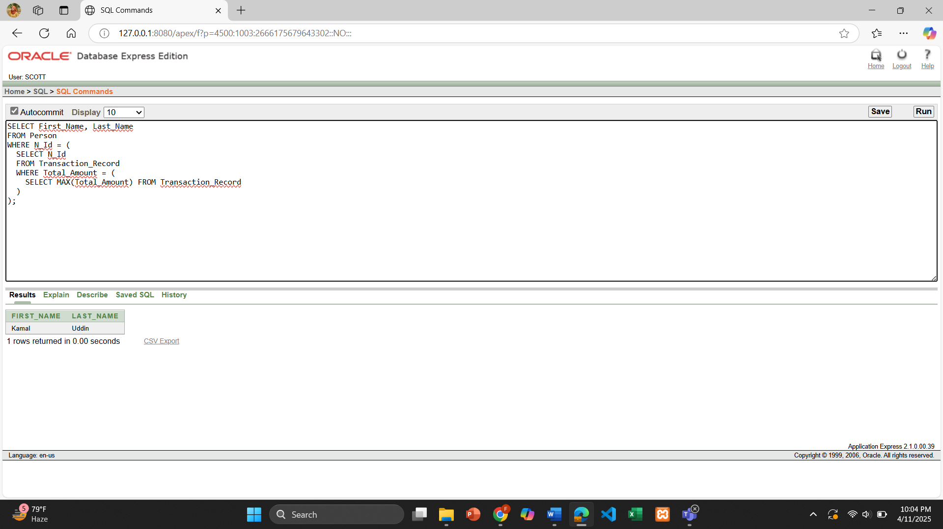

**Question:** Display the bus number and type of buses that have more capacity than the average bus capacity.

2. SELECT Bus_Number, Type

FROM Bus

WHERE Capacity > (

SELECT AVG(Capacity) FROM Bus

);

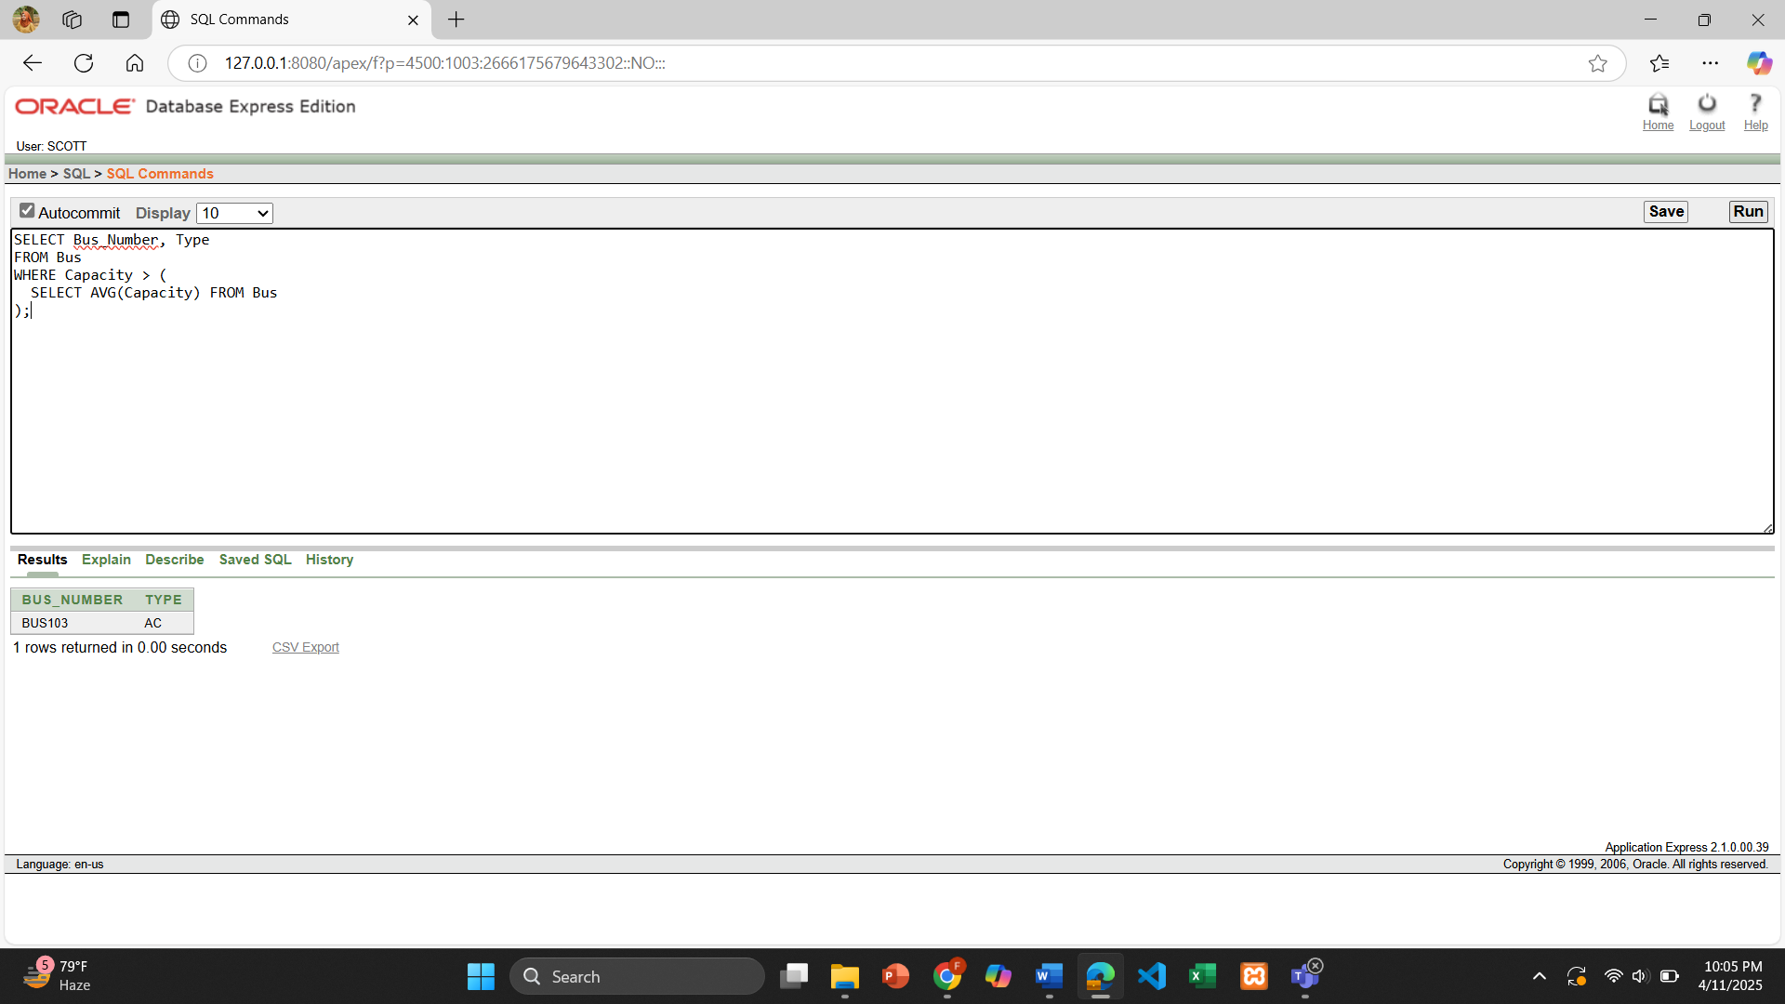

**2 joining**

**Question:** Show the driver name, license number, and the bus model they are assigned to.

1. SELECT P.First_Name || ' ' || P.Last_Name AS Driver_Name, D.License_Number, B.Model

FROM Driver D

JOIN Person P ON D.N_Id = P.N_Id

JOIN Bus B ON D.Bus_Number = B.Bus_Number;

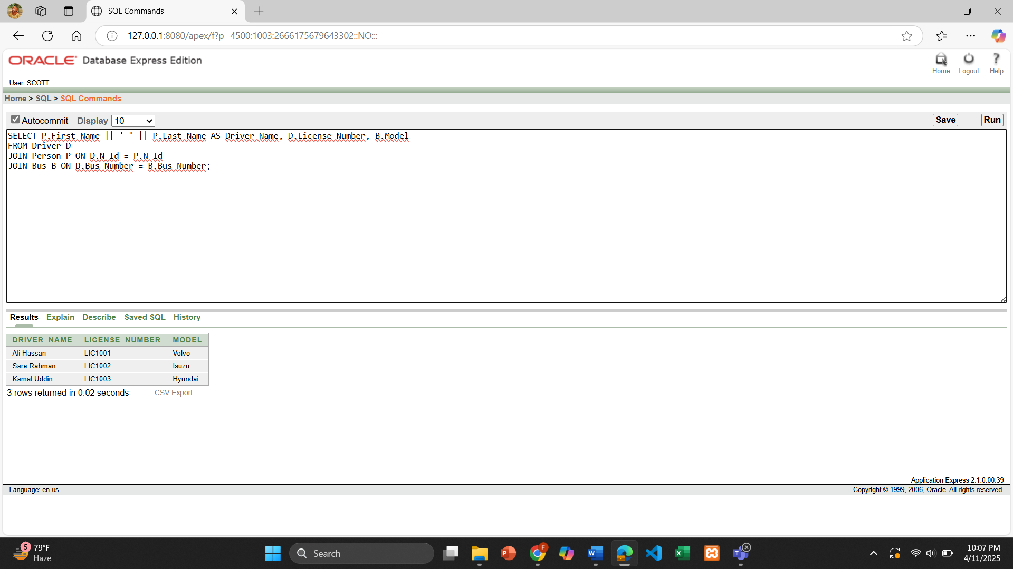

**Question:** Display ticket number, passenger name, and phone number.

2. SELECT TP.Ticket_Number, P.First_Name || ' ' || P.Last_Name AS Passenger_Name, N.Phone_Number

FROM Ticket_Person TP

JOIN Person P ON TP.N_Id = P.N_Id

JOIN Nationality N ON TP.National_Id = N.National_Id;

